

Dr. David, Hill inc.
2016-06-25
Dr. Hill
53662 Michael Ports, New Kevinhaven, NE 62346
Phone: 8408806659
Fax: 5720445227

Re: Jessica, Holmes
PHN: 3402835272
Birthdate: 18-Aug-1950
Address: 61885 Hunt Landing, Dianefurt, NV 49201
Patient number: 8286242809

To Whom It May Concern:

This is a medical letter to state the above patient is pregnant with expected delivery date of 25-Aug-2025. Hoping this information is satisfactory for your requirements.

Thank you.

Sincerely,
Dr. David, Hill
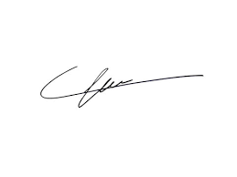
FRCS© NCMP
Clinical Assistant Professor, UBC
Department of Obstetrics and Gynecology SMH

